8 - INFORMATION ON THE NATIONAL HIGHER EDUCATION SYSTEM
Structure and Degree System
The basic structure of the Turkish National Education System consists of stages of noncompulsory pre-school education; compulsory primary (elementary and middle school) and secondary (high school) education; and higher education. Primary education begins at the age of 5.5 (66 months), lasts eight years and comprises elementary and middle school education, four years each. Secondary education is also four years and divided into two categories as "General High School Education" and "Vocational and Technical High School Education". The entry into these categories is through composite scores obtained from a centralized exam for secondary schools.
Higher education system in Turkey is managed by the Council of Higher Education (CoHE, Yükseköğretim Kurulu-YÖK) which is an autonomous public body responsible for the planning, coordination, governance and supervision of higher education within the provisions set forth in the Constitution of the Turkish Republic and the Higher Education Law. Both state and non-profit foundation universities are founded by law and subjected to the Higher Education Law and to the regulations enacted in accordance with it.
Higher education in Turkey comprises all post secondary higher education programmes, consisting of short, first, second, and third cycle degrees in terms of the terminology of the Bologna Process. The structure of Turkish higher education degrees is based on a two-tier system, except for dentistry, pharmacy, medicine and veterinary medicine programmes which have a one-tier system. The duration of these one-tier programmes is five years (300 ECTS) except for medicine which lasts six years (360 ECTS). The qualifications in these one-tier programmes are equivalent to the first cycle (bachelor's) plus second cycle (master's) degree. Undergraduate level of study consists of short cycle (associate's)-(önlisans derecesi) and first cycle (bachelor's)-(lisans derecesi) degrees which are awarded after successful completion of full-time two-year (120 ECTS) and four-year (240 ECTS) study programmes, respectively.
Graduate level of study consists of second cycle (master's)-(yüksek lisans derecesi) and third cycle (doctorate)-(doktora derecesi) degree programmes. Second cycle is divided into two sub-types named as master without thesis and master with thesis. Master programmes without thesis require 60 to 90 ECTS credits and consist of courses and a semester project. 60 ECTS non-thesis master programmes are exceptional, and exist in a few disciplines. The master programmes with a thesis require 90 to 120 ECTS credits, which consists of courses, a seminar, and a thesis. Third cycle (doctorate) degree programmes are completed having earned a minimum of 180 ECTS credits, which consists of completion of courses, passing a proficiency examination and a doctoral thesis. Specialization in medicine, accepted as equivalent to third cycle programmes are carried out within the faculties of medicine, university hospitals and the training hospitals operated by the Ministry of Health.
Universities consist of graduate schools (Institutes) offering second cycle (master’s) and third cycle (doctorate) degree programmes, faculties offering first cycle (bachelor’s degree) programmes, four-year higher schools offering first cycle (bachelor’s) degree programmes with a vocational emphasis and two-year vocational schools offering short cycle (associate’s) degree programmes of a strictly vocational nature.
Since 2003, first cycle degree holders may apply directly to third cycle (doctorate) programmes if their performance at the first cycle degree level is exceptionally high and their national central Graduate Education Entrance Examination (ALES) score is also high and their application is approved. For these students, theoretical part of the programmes requires additional courses of 60 ECTS credits.
Admission of national students to short and first cycle degree programmes is centralized and based on a nationwide one/two-stage examination(s) conducted by an autonomous public body (Assessment, Selection and Placement Centre-ÖSYM). Candidates gain access to institutions of higher education based on their composite scores consisting of the scores on the selection examination and their high school grade point averages. Admission to graduate programmes is directly conducted by the higher education institutions (HEIs) within the frameworks of the publicly available national and institutional regulations. Admission of foreign students to programmes at all levels of higher education can be done by direct applications of candidates to HEIs based on publicly available national and institutional regulations.
The Turkish National Qualifications Framework for Higher Education (TYYÇ): The National Qualifications Framework for Higher Education in Turkey (TYYÇ) developed with reference to the QF for European Higher Education Area and the EQF for lifelong learning was adopted by the CoHE in 2010. The framework has been developed as a part of a single national qualifications framework, which would eventually consists of 8 level national framework covering all levels of educations on completion of the ongoing work at the national level, in which the higher education levels lie on levels between 5 to 8. The levels of the TYYÇ with reference to the European overarching qualifications frameworks as well as that to ECTS credits and student workload are shown below.
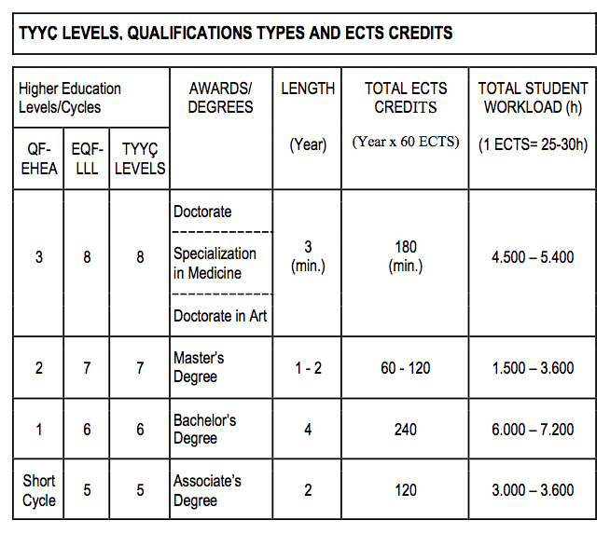 |  | 